Lab - Configure IPv4 and IPv6 Static and Default Routes

Topology
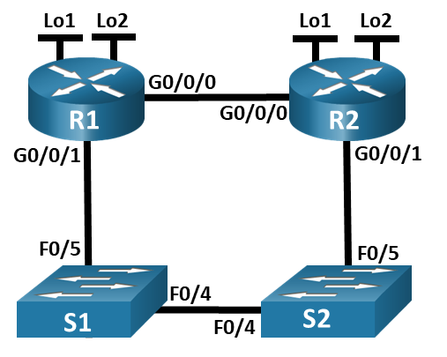

Addressing Table
Device | Interface | IP Address / Prefix
R1 | G0/0/0 | 172.16.1.1 /24
R1 | G0/0/0 | 2001:db8:acad:2::1 /64
R1 | G0/0/0 | fe80::1
R1 | G0/0/1 | 192.168.1.1 /24
R1 | G0/0/1 | 2001:db8:acad:1::1 /64
R1 | G0/0/1 | fe80::1
R1 | Loopback1 | 10.1.0.1 /24
R1 | Loopback1 | 2001:db8:acad:10::1 /64
R1 | Loopback1 | fe80::1
R1 | Loopback2 | 209.165.200.225 /27
R1 | Loopback2 | 2001:db8:acad:209::1 /64
R1 | Loopback2 | fe80::1
R2 | G0/0/0 | 172.16.1.2 /24
R2 | G0/0/0 | 2001:db8:acad:2::2 /64
R2 | G0/0/0 | fe80::2
R2 | G0/0/1 | 192.168.1.2 /24
R2 | G0/0/1 | 2001:db8:acad:1::2 /64
R2 | G0/0/1 | fe80::2
R2 | Loopback1 | 10.2.0.1 /24
R2 | Loopback1 | 2001:db8:acad:11::2 /64
R2 | Loopback1 | fe80::2
R2 | Loopback2 | 209.165.200.193 /27
R2 | Loopback2 | 2001:db8:acad:210::1 /64
R2 | Loopback2 | fe80::2

Objectives
Part 1: Build the Network and Configure Basic Device Settings
Part 2: Configure and verify IP and IPv6 addressing on R1 and R2
Part 3: Configure and verify static and default routing for IPv4 on R1 and R2
Part 4: Configure and verify static and default routing for IPv6 on R1 and R2

Background / Scenario
Static and Default routing are the simplest forms of network routing and configured manually. They are fixed, meaning that they do not change dynamically to meet changing network conditions. They are either valid and made available to the routing table or invalid and not made available to the routing table. Static routes have an administrative distance of one by default. However, static and default routes can be configured with an administrator-defined administrative distance. This capability allows the administrator to put the static or default route in reserve, and only make it available to the routing table when routes with lower administrative distances (usually generated by dynamic routing protocols) are no longer valid.
Note: In this lab you will configure static, default, and floating default routes for both IPv4 and IPv6 which may not reflect networking best practices.
Note: The routers used with CCNA hands-on labs are Cisco 4221 with Cisco IOS XE Release 16.9.4 (universalk9 image). The switches used in the labs are Cisco Catalyst 2960s with Cisco IOS Release 15.2(2) (lanbasek9 image). Other routers, switches, and Cisco IOS versions can be used. Depending on the model and Cisco IOS version, the commands available and the output produced might vary from what is shown in the labs. Refer to the Router Interface Summary Table at the end of the lab for the correct interface identifiers.
Note: Ensure that the routers and switches have been erased and have no startup configurations. If you are unsure contact your instructor.

Required Resources
- 2 Routers (Cisco 4221 with Cisco IOS XE Release 16.9.4 universal image or comparable)
- 2 Switches (Cisco 2960 with Cisco IOS Release 15.2(2) lanbasek9 image or comparable)
- 1 PC (Windows with a terminal emulation program, such as Tera Term)
- Console cables to configure the Cisco IOS devices via the console ports
- Ethernet cables as shown in the topology

Instructions

Build the Network and Configure Basic Device Settings
In Part 1, you will set up the network topology and configure basic settings on the PC hosts and switches.

Cable the network as shown in the topology.
Attach the devices as shown in the topology diagram, and cable as necessary.

Configure basic settings for each router.
      - Assign a device name to the router.
Open configuration window
      - Disable DNS lookup to prevent the router from attempting to translate incorrectly entered commands as though they were host names.
      - Assign class as the privileged EXEC encrypted password.
      - Assign cisco as the console password and enable login.
      - Assign cisco as the VTY password and enable login.
      - Encrypt the plaintext passwords.
      - Create a banner that warns anyone accessing the device that unauthorized access is prohibited.
      - Save the running configuration to the startup configuration file.
Close configuration window

Configure basic settings for each switch.
Open configuration window
      - Assign a device name to the switch.
      - Disable DNS lookup to prevent the router from attempting to translate incorrectly entered commands as though they were host names.
      - Assign class as the privileged EXEC encrypted password.
      - Assign cisco as the console password and enable login.
      - Assign cisco as the VTY password and enable login.
      - Encrypt the plaintext passwords.
      - Create a banner that warns anyone accessing the device that unauthorized access is prohibited.
      - Shutdown all interfaces that will not be used.
      - Save the running configuration to the startup configuration file.

Question:
Issuing the command show cdp neighbors at this point on R1 or R2 results in an empty list. Explain.
Type your answers here.
Close configuration window

Configure and verify IPv4 and IPv6 addressing on R1 and R2
In Part 2, you will configure and verify the IPv4 and IPv6 addresses on R1 and R2. Use the table above for the information necessary to complete this part.

Configure IP addresses for both routers.
Open configuration window
      - Enable IPv6 Unicast Routing on both routers.
      - Configure the IP address for all the interfaces according to the Addressing Table.

Verify addressing
      - Issue the command to verify IPv4 assignments to the interfaces.
      - Issue the command to verify IPv6 assignments to the interfaces.

Save your configuration
Save the running configuration to the startup configuration file on both routers.
Close configuration window

Configure and verify static and default routing for IPv4 on R1 and R2
In Part 3, you will configure static and default routing on R1 and R2 to enable full connectivity between the routers using IPv4. Once again, the static routing being used here is not meant to represent best practice, but to assess your ability to complete the required configurations.

On R1, configure a static route to R2’s Loopback1 network, using R2’s G0/0/1 address as the next hop.
open configuration window
      - Use the ping command to ensure that R2’s G0/0/1 interface is reachable.
      - Configure a static route for R2’s Loopback1 network via R2’s G0/0/1 address.

On R1, configure a static default route via R2’s G0/0/0 address.
      - Use the ping command to ensure that R2’s G0/0/0 interface is reachable.
      - Configure a static default route via R2’s G0/0/0 address.

On R1, configure a floating static default route via R2’s G0/0/1 address.
Configure a floating static default route with an AD of 80 via R2’s G0/0/1 address.

On R2, configure a static default route via R1’s G0/0/0 address
      - Use the ping command to ensure that R1’s G0/0/0 interface is reachable.
      - Configure a static default route via R1’s G0/0/0 address.

Verify that the routes are operational.
      - Use the show ip route command to ensure that R1’s routing table shows the static and default routes.
      - On R1, issue the command traceroute 10.2.0.1. The output should show that the next hop is 192.168.1.2.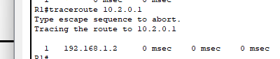
      - On R1, issue the command traceroute 209.165.200.193. The output should show that the next hop is 172.16.1.2.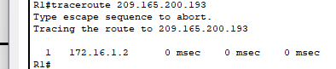
      - Issue the shutdown command on R1 G0/0/0.
      - Demonstrate that the floating static route is working. First, issue the show ip route static command. You should see two static routes. A default static route with an AD of 80 and a static route to the 10.2.0.0/24 network with an AD of 1. 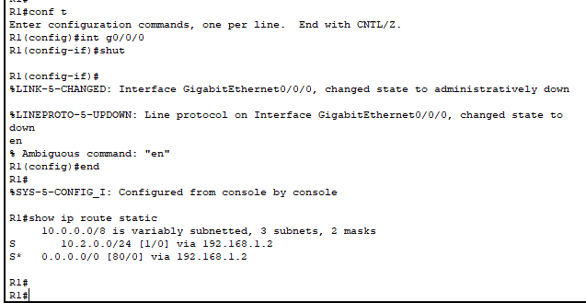
      - Demonstrate the floating static route is working by issuing the traceroute 209.165.200.193 command. The traceroute will show the next hop as 192.168.1.2.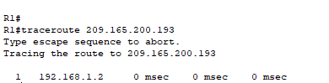
      - Issue the no shutdown command on R1 G0/0/0.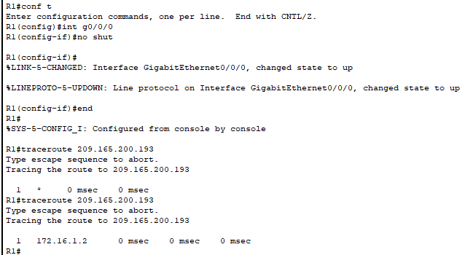
Close configuration window

Configure and verify static and default routing for IPv6 on R1 and R2
In Part 4, you will configure static and default routing on R1 and R2 to enable full connectivity between the routers using IPv6. Once again, the static routing being used here is not meant to represent best practice, but to assess your ability to complete the required configurations.

On R2, configure a static route to R1’s Loopback1 network, using R1’s G0/0/1 address as the next hop.
Open configuration window
      - Use the ping command to ensure that R1’s G0/0/1 interface is reachable.
      - Configure a static route for R1’s Loopback1 network via R1’s G0/0/1 address.

On R2, configure a static default route via R1’s G0/0/0 address.
      - Use the ping command to ensure that R1’s G0/0/0 interface is reachable.
      - Configure a static default route via R1’s G0/0/0 address.

On R2, configure a floating static default route via R1’s G0/0/1 address.
Configure a floating static default route with an AD of 80 via R1’s G0/0/1 address.

On R1, configure a static default route via R2’s G0/0/0 address.
      - Use the ping command to ensure that R2’s G0/0/0 interface is reachable.
      - Configure a static default route via R2’s G0/0/0 address.

Verify that the routes are operational.
      - Use the show ipv6 route command to ensure that R2’s routing table shows the static and default routes.
      - On R2, issue the command traceroute 2001:db8:acad:10::1. The output should show that the next hop is 2001:db8:acad:1::1.
      - On R2, issue the command traceroute 2001:db8:acad:209::1. The output should show that the next hop is 2001:db8:acad:2::1.
      - Issue the shutdown command on R2 G0/0/0.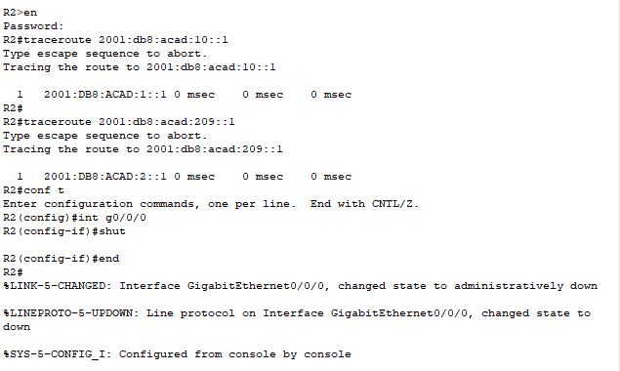
      - Demonstrate the floating static route is working. First issue the show ipv6 route static command. You should see two static routes. A default static route with an AD of 80 and a static route to the 2001:db8:acad:10::/64 network with an AD of 1.
      - Lastly, demonstrate that the floating static route is working by issuing the traceroute 2001:db8:acad:209::1 command. The traceroute will show the next hop as 2001:db8:acad:1::1.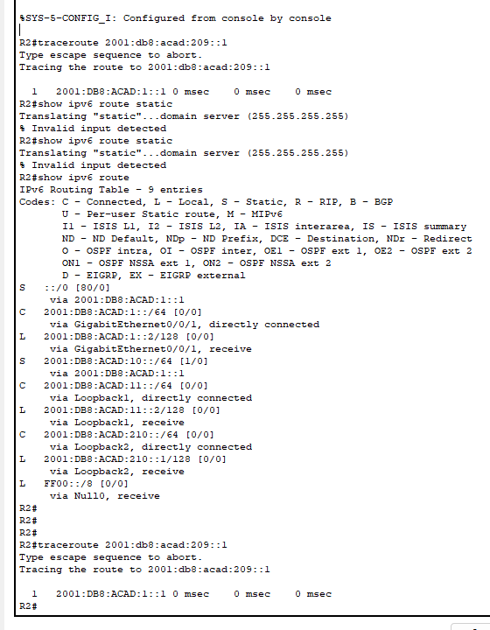
Close configuration window
- Router Interface Summary Table
Router Model | Ethernet Interface #1 | Ethernet Interface #2 | Serial Interface #1 | Serial Interface #2
1800 | Fast Ethernet 0/0 (F0/0) | Fast Ethernet 0/1 (F0/1) | Serial 0/0/0 (S0/0/0) | Serial 0/0/1 (S0/0/1)
1900 | Gigabit Ethernet 0/0 (G0/0) | Gigabit Ethernet 0/1 (G0/1) | Serial 0/0/0 (S0/0/0) | Serial 0/0/1 (S0/0/1)
2801 | Fast Ethernet 0/0 (F0/0) | Fast Ethernet 0/1 (F0/1) | Serial 0/1/0 (S0/1/0) | Serial 0/1/1 (S0/1/1)
2811 | Fast Ethernet 0/0 (F0/0) | Fast Ethernet 0/1 (F0/1) | Serial 0/0/0 (S0/0/0) | Serial 0/0/1 (S0/0/1)
2900 | Gigabit Ethernet 0/0 (G0/0) | Gigabit Ethernet 0/1 (G0/1) | Serial 0/0/0 (S0/0/0) | Serial 0/0/1 (S0/0/1)
4221 | Gigabit Ethernet 0/0/0 (G0/0/0) | Gigabit Ethernet 0/0/1 (G0/0/1) | Serial 0/1/0 (S0/1/0) | Serial 0/1/1 (S0/1/1)
4300 | Gigabit Ethernet 0/0/0 (G0/0/0) | Gigabit Ethernet 0/0/1 (G0/0/1) | Serial 0/1/0 (S0/1/0) | Serial 0/1/1 (S0/1/1)
Note: To find out how the router is configured, look at the interfaces to identify the type of router and how many interfaces the router has. There is no way to effectively list all the combinations of configurations for each router class. This table includes identifiers for the possible combinations of Ethernet and Serial interfaces in the device. The table does not include any other type of interface, even though a specific router may contain one. An example of this might be an ISDN BRI interface. The string in parenthesis is the legal abbreviation that can be

Topology

Slot
18
19

R1
R2
S1
S2
21
22

T22

C
C
T23
T24

C

C

C

C
F0/4
F0/5

g0/0/0
g0/0/1
F0/5
F0/4
g0/0/1
g0/0/0

- Console - nw admin/engineer
  - Do data transmission?
  - Configure device
  - Wont lost connection on plug to different devices (like to sw to router, very fast one
- Network connection

auto-mdix helps negotiate both crossover and straight through cable, redirect the data to the correct pin at the receiver side through software.
* Suggested use back the correct cable, especially router to router connection

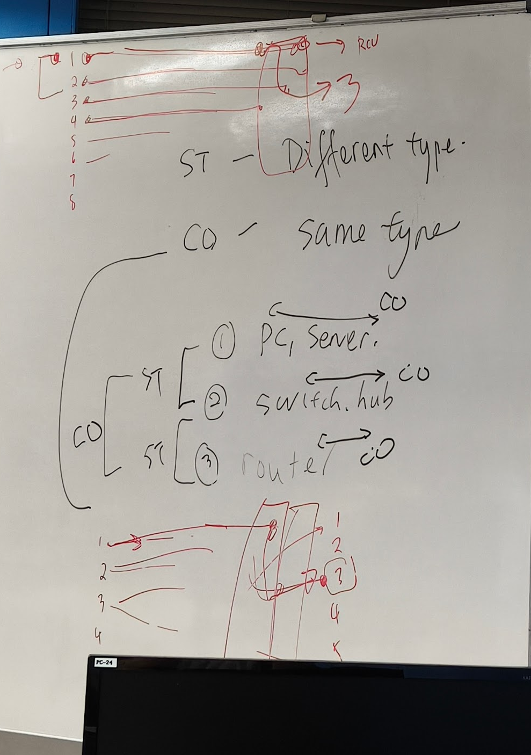
Console connection
- Table num = Patch Panel (where all cable to console port
- Always 1 St cable (no worry on type
- Find slot (sw / router)
- Putty select serial, check is com1 (pwd: class,cisco)
  - #write erase
  - #delete flash:vlan.dat (router no step 2, as no vlan database
  - #reload
- Confirm
  - #show run - must empty
  - #copy r s

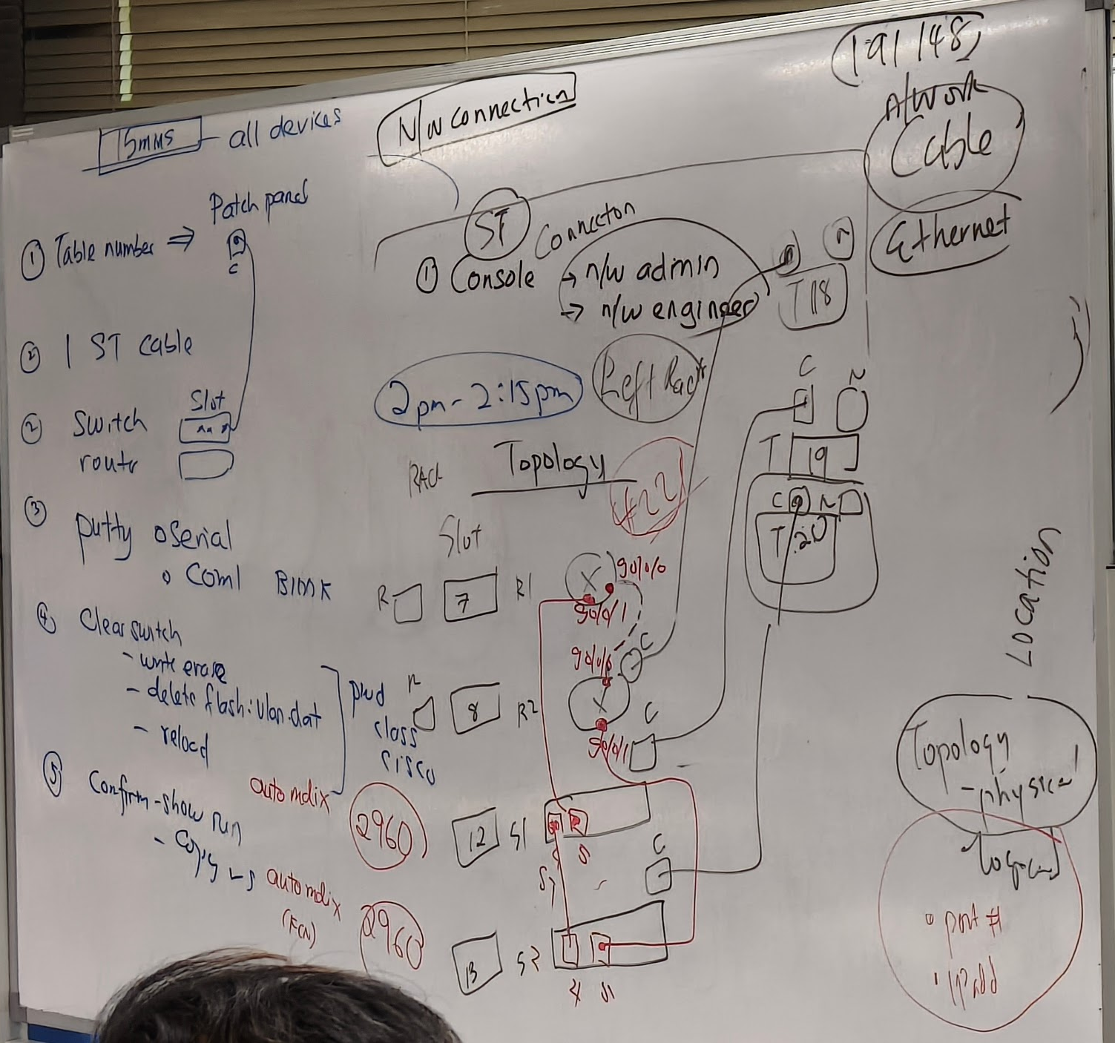
#R1
en
conf t
hostname R1
no ip domain-lookup
enable secret class
line con 0
pass cisco
login
line vty 0 4
pass cisco
login
service password-encryption
banner motd $ Authorized Users Only! $

ipv6 unicast-routing

int g0/0/0
ip add 172.16.1.1 255.255.255.0
ipv6 add fe80::1 link-local
ipv6 add 2001:db8:acad:2::1/64
no shut

int g0/0/1
ip add 192.168.1.1 255.255.255.0
ipv6 add fe80::1 link-local
ipv6 add 2001:db8:acad:1::1/64
no shut

int lo1
ip add 10.1.0.1 255.255.255.0
ipv6 add fe80::1 link-local
ipv6 add 2001:db8:acad:10::1/64
no shut

int lo2
ip add 209.165.200.225 255.255.255.224
ipv6 add fe80::1 link-local
ipv6 add 2001:db8:acad:209::1/64
no shut

ip route 10.2.0.0 255.255.255.0 192.168.1.2
ip route 0.0.0.0 0.0.0.0 172.16.1.2
ip route 0.0.0.0 0.0.0.0 192.168.1.2 80
ipv6 route ::/0 2001:db8:acad:2::2

end
wr

#R2
en
conf t
hostname R2
no ip domain-lookup
enable secret class
line con 0
pass cisco
login
line vty 0 4
pass cisco
login
service password-encryption
banner motd $ Authorized Users Only! $

ipv6 unicast-routing

int g0/0/0
ip add 172.16.1.2 255.255.255.0
ipv6 add fe80::2 link-local
ipv6 add 2001:db8:acad:2::2/64
no shut

int g0/0/1
ip add 192.168.1.2 255.255.255.0
ipv6 add fe80::2 link-local
ipv6 add 2001:db8:acad:1::2/64
no shut

int lo1
ip add 10.2.0.1 255.255.255.0
ipv6 add fe80::2 link-local
ipv6 add 2001:db8:acad:11::2/64
no shut

int lo2
ip add 209.165.200.193 255.255.255.224
ipv6 add fe80::2 link-local
ipv6 add 2001:db8:acad:210::1/64
no shut

ip route 0.0.0.0 0.0.0.0 172.16.1.1
ipv6 route 2001:db8:acad:10::/64 2001:db8:acad:1::1
ipv6 route ::/0 2001:db8:acad:2::1
ipv6 route ::/0 2001:db8:acad:1::1 80

end
wr

#S1
en
conf t
hostname S1
no ip domain-lookup
enable secret class
line con 0
pass cisco
login
line vty 0 15
pass cisco
login
service password-encryption
int range f0/1-3, f0/6-24, g0/1-2
shut
end
wr

#S2
en
conf t
hostname S2
no ip domain-lookup
enable secret class
line con 0
pass cisco
login
line vty 0 15
pass cisco
login
service password-encryption
int range f0/1-3, f0/6-24, g0/1-2
shut
end
wr

conf t
int g0/0/0
shut
end

End of document

